Title

Author Name1, Author Name2, Author Name3

Affiliation University, School, Department, Institute
Address, City, Postal Code, Country
E-mail
Keywords: Keyword1, Keyword2, Keyword3
Abstract
The purpose of these instructions is to serve as a guide for formatting papers to be published in the Proceedings of the 6th International Symposium on Thermal-Fluid Dynamics, Qingdao, China, July 24-27, 2025. The abstract should include an introductory statement that outlines the background and significance of the study, the methodologies, as well as the major findings of the study. Do not side any references, figures, equations, or tables in the abstract. At least four keywords or phrases should be given in alphabetical order.

Introduction
The purpose of these instructions is to serve as a guide for formatting papers to be published in the Proceedings of the 6th International Symposium on Thermal-Fluid Dynamics, Qingdao, China, July 24-27, 2025.
The manuscripts should be written in English. The figure, table, equation should be inserted in the full text. And the references should be included. The full text must be formatted strictly according to these instructions.
Experimental Facility / Numerical Methods / etc.
You can describe in this section, your experimental facility, numerical methods, etc. You can change the title of this and other sections to fit the text. You can also include figures, equations, etc.
One Example of Figure
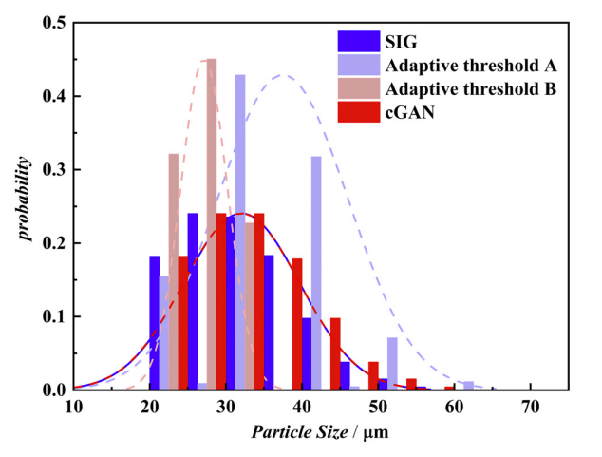
Figure 1: Place here the figure caption.
Equations
One blank line must be included above and below each equation.

$$\left[M\right]\left\{\overset{¨}{x}\left(t\right)\right\}+\left[C\right]\left\{\overset{˙}{x}\left(t\right)\right\}+\left[K\right]\left\{x\left(t\right)\right\}=f\left(t\right)$$ | (1)
$$M\overset{¨}{x}\left(t\right)+C\overset{˙}{x}\left(t\right)+\text{Kx}\left(t\right)=f\left(t\right)$$ | (2)
Citations
Please list the references following the examples in the end of this template (Wallis 1969; Bagnold 1954; Taitel & Barnea 1993).
Results and Discussion
Use this section to describe your results. You can change the title of the section, and you can include figures and tables.
One Example of Table
Table 1 Specifications of the test section
Case No. | 1 | 2 | 3 | 4
d_{p}(mm) | 5 | 6 | 7 | 8
Length(mm) | 260.48 | 311.80 | 364.67 | 361.33
Width(mm) | 45 | 54 | 63 | 72
Height(mm) | 6.58 | 7.9 | 9.22 | 10.53
Conclusions
Describe briefly in this section the main conclusions of your work.
Acknowledgements
This optional section must be placed before the list of references.
References
Bagnold, R. A. Experiments on a gravity-free dispersion of large solid spheres in a Newtonian fluid under shear. Proc. R. Soc. Lond. A, Vol. 225, pp. 49 – 63 (1954)
Taitel, Y. & Barnea, D. A model for slug length distribution in gas-liquid slug flow. Int. J. Multiphase Flow, Vol. 19, pp. 829 – 838 (1993)
Wallis, G. B. One-dimensional two-phase flow. McGraw- Hill, (1969)

